Quimper Unitarian Universalist Fellowship
Board of Trustees
Minutes for February 26, 2025 6:00 pm
RE 2/3 and Via Zoom

Present: Gary Forbes, Mary Tucker, Bill Testerman, Dean Carr, Roseanna Almaee, Julia Cochrane, Megan Cate, Sarah Walker, Rev. Linda Hart, observer Jenell DeMatteo

Meeting Called to Order 6:00

Spiritual Practice and Opening
Chalice Lighting – Linda
Check-in

Protocol for observers during virtual or hybrid meetings:
- All non-board members will be muted and video turned off
- Observers may be asked to respond to a question (e.g., parliamentarian for a question on process)
- Invited observers with items on the Agenda may be asked to join when that agenda item is being discussed

Opening Announcements or acknowledgements 6:10
--Assign process and time observer--Gary
--The Board is appreciative of the wonderful Sunday Service presented by our youth February 22. (Card for youth signed by all members of the Board)
--The Board sponsored the first of 6 concerts scheduled for this spring
--The Board officers and the staff had the opportunity to meet with our Western District primary contact: Sarah Gibbs-Millspaugh Monday, February 24th. Roseanna gave an update on Sarah and her family.
--March 10 1:00-2:30 Fire drill and other safety drill training. Ushers and greeters have been informed. It would be good for Board members to attend.

Approve Meeting Agenda
Moved: Roseanna – Seconded: Gary – Approved

Consent Agenda
- Approval of Minutes of January 22, 2025 meeting
- Approve appointment of Amy Hepburn verifying the Electronic vote completed February 1, 2025: “The Board approves the recommendation from the Nominations Committee that Amy Hepburn be appointed to fill the vacant position on the Endowments Committee to serve for the remainder of the year completing her term as of June 30 2025.“
- Approve of pending Sexual Misconduct policy (no additional input received from the Fellowship)
- Moved: Dean – Seconded: Roseanna – Approved

Standing Reports
- President’s Report – see Attachment A
- Minister’s Report – see Attachment B
- Treasurer’s Report – see Attachment C

Motion to approve Treasurer’s Report (Dashboard is attached to the email with this agenda)
Moved: Peg – Seconded: Gary – Approved

--Approval of Pending Policy for the donation jar – see Attachment L)

Discussion: Karl Bach’s suggestion for a wording addition: May I suggest an addition to the wording of: "Free Public Events (coordinated by QUUF) are held at QUUF will have a donation jar available for voluntary donations." Add "to QUUF" at the end of this sentence. In my opinion this would clarify the intention of the donation jars.
Moved: Roseanna – Seconded: Dean – Approved

--Information: The Finance committee authorizes a $10 fee, rather than the previously agreed on 10% administrative fee for Women’s Retreat, Men’s Retreat, Quimper Camp and OWL, and following years will revert to the policy of 10%.

BREAK

Trustees’ Reports – Congregational Committees
- Endowments – Mary T. Endowments met yesterday. People who have signed up for a niche in the columbarium have been asked to redo their information.

- Nominating Committee – see Attachment D – Gary F. Gary went over the election process schedule. Open house after the service 3/9. Gary will get an announcement to Linda and Peg (announcer for Sunday 3/2). Four open positions on the Board, openings on Nominating and perhaps on Endowments. Board candidates need to be posted six weeks before elections, according to the bylaws. Voting needs to be completed by April 27. Candidates must be listed by March 16. Christina encouraged members of the Nominating Committee to check with the office about deadlines. The Board has to decide and put out information on the voting method.

- The Board voted on electronic voting for the 2025 election using the process we did last year.

Moved: Roseanna – Seconded: Julia – Approved

Program Council Report – see Attachment E

Board Task Force and Committee Reports

Communications Subcommittee – (no report) – Peg H. Roseanna will share a draft of a Monday Board Report for comment by Board members. It will be mailed out on Monday, March 3.

Governance Committee – (no report) – Julia C. Committee is talking about self-assessment of the governance process. The committee reports to the Board quarterly, so we will expect a March report. Julia mentioned that congregational goals will help the GC do their assessment.

Denominational Affairs – (no report) – Julia C. There will be announcements coming regarding this year’s GA. Dean: be sure there is notification about when the registration price changes. Information about this can be found in the policy manual.

Personnel Committee – see Attachment I – Roseanna A.
Motion to post to Pending Policies
Moved: Mary – Second: Dean – Approved

This will be posted on the website as a pending policy for 30 days, open for the congregation to comment, then voted on by the Board. Need a notice in the Update this week.

Review progress and timelines for Board Goals – see Attachment J
--Mission workshop data

Discussion prompt for Developmental ministry goals – see Attachment K

Donation Jar pending policy text for review – see Attachment L

Extinguishing the Chalice:

<Closing Words>
ADJOURN: The meeting was adjourned at 8:05.
Moved: Roseanna – Seconded: Bill – Approved

References

Open Questions for QUUF Vision building from 2021 BoT Retreat

Together how can we better meet the spiritual needs of our community?
How can we create a more unified, diverse, equitable and inclusive
QUUF community for all?
QUUF Board Covenant (revised 9/14/15)
As Board members of the Quimper Unitarian Universalist Fellowship, we will:

- Hold in love all that we do for QUUF and the Board. Love serves to make service on the Board a spiritual experience.
- Listen mindfully and deeply, encourage each other, work toward trusting relationships in order to transcend our individual limitations and achieve a greater result.
- Seek consensus, honoring dissenting opinions. We will speak with one voice about Board decisions once they are made.
- Be prepared to achieve the goals we collectively set, keeping in mind the spirit, cooperation, and joy.
- Resolve our conflicts in a timely manner. Forgive each other and ourselves.
- Speak honestly and be discerning about what needs to be kept confidential.
- Express sincere appreciation of each other.
- Maintain a sense of humor.
- Represent the congregation by listening to their concerns and dreams and by acting in their best interest.
- Be guided by the Seven Principles.

- Updated: 10-11-2024 | Sarah W. | Roseanna | Peg | Julia | Mary | Gary | Megan | Dean | Bill
Number of Assignments
Officers
President | X
Vice President |  | X
Secretary |  |  | X | X
Treasurer |  |  |  |  | X
Executive Team | X | X | X |  | X
Standing Committees
Finance –Treas required by bylaws |  |  |  |  | X
Endowments Treas required by bylaws |  |  |  |  | X
Nominating- Chosen by board members, and is a voting member of committee |  |  |  |  |  | X
Personnel |  | X
Board Committees/Task Forces
Communications |  |  | X
Governance Committee |  |  |  | X
RAMP |  |  |  |  | X |  | X
GOALS-LEADERSHIP
Finance |  |  |  |  | X |  | X
Nominations - Governance |  |  |  |  |  | X
Mission |  |  |  |  |  |  |  | X
Developmental Ministry | X | X
Board Procedures |  |  | X | X
Fellowship Meeting & Annual Meeting | X | X | X | X | X | X | X | X
Pending Committees/Task Forces
Long Range Planning (5-Yr plan) – not yet formed-requires board action
Leadership Dev. Program – not yet formed-requires board action
(1) Treasurer member per bylaws
(2) Elected from Board Members as voting member

Attachment A
President’s Report
February 23, 2025

Mission: I have been actively involved throughout the month in helping with the Searching for the Future Forum in collaboration with the lead organizer Dean Carr, Gary Forbes, and our consultant Rachel Maxwell. Following the workshop, we are determining the best ways to preserve and interpret the data that was shared by the 100 or so participants. We have the complete transcription of prompts given to small discussion groups to record what we love about QUUF, what makes us feel most engaged, and a future headline we can imagine for QUUF five years from now. We also have the vision statements and mission statements contributed by all the groups. Now our wordsmiths are crafting statements for further consideration by the Fellowship as a whole. Peg Hunter wrote a Monday Board Report to share the overview of the event and what happens next. Robin Stemen is integrating some of the positive energy from the workshop into the Stewardship messaging.

Issues: I have done some collaborative research regarding the issues of Sanctuary, UUA guidelines for called ministry, personnel severance policy, and disruptive persons safety protocol. I appreciate the advice of the other board officers and staff in the process of preparing for our board Study Session and meeting.

Goal Setting: I have communicated with Linda and the Program Council chair on the topic of formulating the next set of Developmental Ministry goals for the coming year. We will be collaborating with Linda to establish priorities for her 2025-2026 contract. The Board is reviewing our Board Goals this month.

Meetings and activities: I attended the first of three Responding to Now training sessions with the Pacific Western District staff on February 6. I am scheduled to welcome our Western District primary contact, Sarah Gibbs-Millspaugh on February 24 on a quick visit to take a tour of QUUF and join the Board officers and available staff in conversations and lunch. (Linda is out of town). And I have been able to attend a Friendship dinner, an ALSO class discussion of the book The Serviceberry by Robin Wall Kimmerer, the ALSO spirit box craft workshop, the Dining for Dollars Sound of Music sing-along and many more events are on the horizon!

A highlight for me this month has been the wonderful youth service that was provided this recent Sunday, February 23. There was a great audience for their wonderful talent and thoughtful encouragement toward activism. We are so proud of our youth and grateful for the guidance of our Director of Family ministry and youth advisors.

Respectfully,
Sarah Walker, President
QUUF Board of Trustees
Return to Agenda
Attachment B
Monthly Minister’s Board Report

{Paste Report here}

Return to Agenda

Attachment D
Nominating Committee Report

2025 Timeline for Candidacy
March 2 Candidate Open House
March 11 Applications for the Board of Trustees, Endowments, and Nominating Committee are due to Nominating@quuf.com.
March 14 Written notice of slate is published
April 6 Petitions for candidacy for Board of Trustees, Endowments, and Nominating Committee are due to Nominating@quuf.com. Must be signed by 25 QUUF members, or 10% of total QUUF membership, whichever is greater.
April 11 Ballots sent to QUUF members.
April 13 Candidate forum
April 27 Ballots due, as per Bylaws.

Proposed ALTERNATE 2025 Timeline for Candidacy
March 9 Candidate Open House
March 16 Publish preliminary list of Committee nominees (6 wks)
March 25 Applications for the Board of Trustees, Endowments, and Nominating Committee are due to Nominating@quuf.com.
April 6 Petitions for candidacy for Board of Trustees, Endowments, and Nominating Committee are due to Nominating@quuf.com. Must be signed by 25 QUUF members, or 10% of total QUUF membership, which ever is greater. (3 wks)
April 11 Ballots sent to QUUF members.
April 13 Candidate forum
April 27 Ballots due, as per Bylaws.

Summary of Nominating Committee Meeting
2/13/25

The committee reviewed the timeline for elections (appended) to assure as much time as possible for potential leaders to indicate their interest and make application. The committee pledges to personally contact all applicants. It would be very helpful for each elected body to provide a description of desirable skills needed to serve, and to ensure that all new leaders have a mentor assigned to them as they begin their term of service. An updated description of the duties of elected positions is also requested.

We discussed suggesting that each elected group might want to submit names of QUUF members who might be good candidates to serve in that group.

The Nominating Committee will hold an open house in early March (still waiting for definite answer but likely after service on March 9). We will ask a member of each elected body to speak briefly about their experience of service to the congregation.

Regarding leadership development, there has not been a great deal of progress made on this topic, but it is clear that a broad-based approach including contributions from both elected and non-elected leaders is necessary. We have had preliminary discussions with members of the Program Council and seek additional guidance from the board.

Return to Agenda

Attachment E
Program Council Report


Program Council – Report to the Minister
February 20, 2025
Program Council
The Mini Forest Project has been discontinued due to lack of engagement. Elizabeth will still focus on the pollinator garden (which was supposed to be stage one of the project).

We are planning on a different style of Leadership program for the 3rd (and last) one this church year in March or April: We are planning on working with the proposed Mission statement within the Councils, Teams, and Committees with conversation prompts. Tentatively:
- How does this make you feel? (hopeful, inspired, challenged, excited?)
- How does this mission statement inform/shape the work of your team/committee/council?
- Anything else come up for you?
The Program Council discussed the plan to add administrative fees to the cost of the Women’s, Men’s Retreats and Quimper Camp. We reached a consensus in our opinion that 10% is too high. We understand the 3% processing fee for cards. The reason we object to the 10% fee is that these are part of our church ministry. We already pay pledges (and participate in multiple other fundraisers) We don’t want to be ‘nickel and dimed”.

The Program Council discussed and approves of the two pending policies.

The Program Council has begun a discussion, based on Sarah’s request to review how we are doing with regard to the Ministry goals.

We have created a form for new teams to use when starting a new Team. We need to complete establishing the procedures that go with the form. Currently new Teams include: Dances of Universal Peace and Dinner and Discussion (taking the place of AHA)

Ongoing
For coordination and communication, the PC chair Diane meets monthly with Linda, attends the Governance Committee meetings and Executive Board Committee meetings as a liaison from the Program Council.
We will be helping provide information to RAMP for the monthly Report on Ministry.
We will collaborate with others to determine what is needed for Leadership Training and who will do what.

Councils – and some highlights
Community Council – Women’s Retreat planning is well on the way. Kate Kinney and Rosemary Adang are the co-leads. Peg Hunter is the secretary.
The HCT are making a few revisions to the Right Relations Covenant.
Membership & Belonging Team have started informal monthly gathering for visitors once a month after the Sunday service. There will be approximately 15 new members for the next ceremony of signing the book.
Social and Environmental Justice Council
Antiracism Team is coordinating with and sponsoring several meetings for community organizations that support their mission. New: sponsoring a dramatic reading of “One Family in Gaza”.
SEJC is hosting JIAC (Jefferson Interfaith Action Coalition) discussions on Sanctuary. Two tracks: Coordination among the churches and education within our congregation.
The Housing Action Team has committed to providing 5 dinners a month at the Emergency Shelter at the Legion. There will be sign-ups for helping with meals. Teams are encouraged to participate.
Spirit Council – Susan Landau has stepped down as Lead. We are actively seeking a replacement. We want to re-energize the Spirit Council and especially the Sunday Services Team in the coming year.
Growth and Learning Council – We are looking for a new Lead for Growth and Learning Council.
ALSO (Advancing Learning and Spiritual Opportunities) classes are in progress. Offerings for next year are in progress.
Widening the Circle Team continues to contribute ‘Tid Bits’ to the Friday Update.
Members are taking an introductory class offered through the UUA Mosaic Program. The Mosaic Program is a new antiracist, anti-oppression, multicultural curriculum. This is a prerequisite in order to utilize the new curriculum.
Operations Council – meets quarterly.
Jenell is organizing a training for ushers and greeters on the emergency evacuation plans.
Stewardship Team doing well; plans are under way. Dining for Dollars – just completed.
The Accessibility Team is on hold.
FOST – completed archway, is planning a pruning party, working on the chancel stage.

Submitted by Diane Haas, Program Council Chair

Upcoming Events
Concerts – 6 scheduled
Women’s Retreat – March 21-23
Mystery Pals Find out – March 30
A Family in Gaza – March 30
Brunch-a-Palousa – April 6
Return to Agenda
Data Report on Ministry
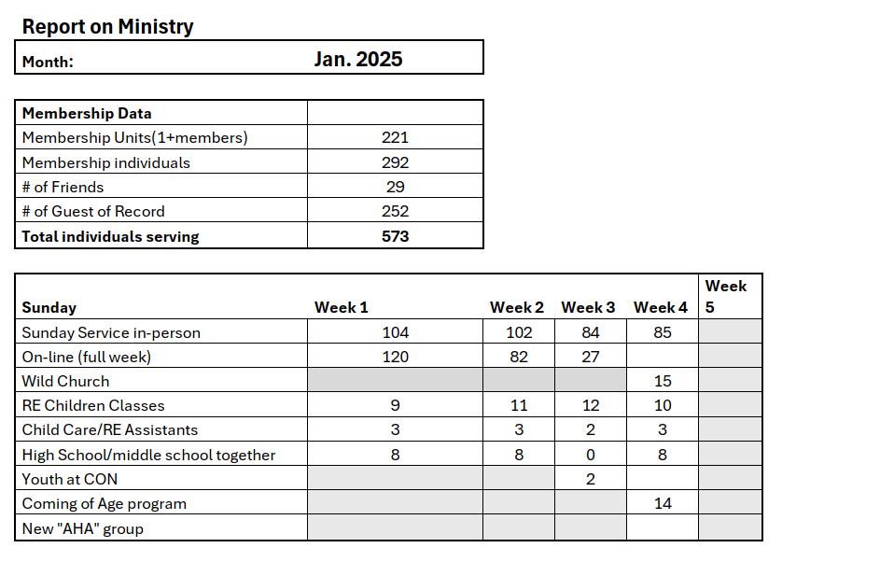
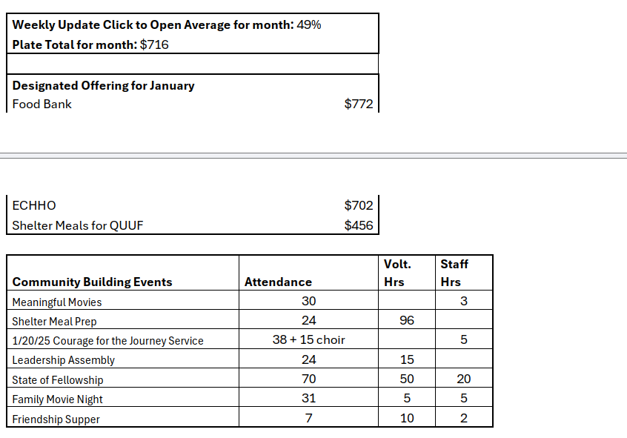
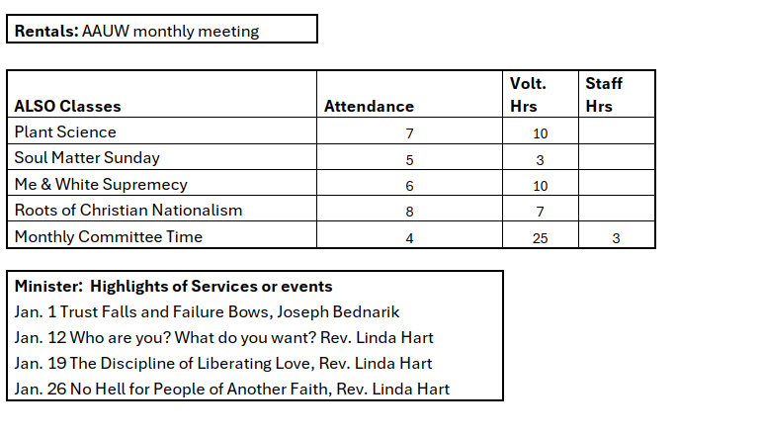
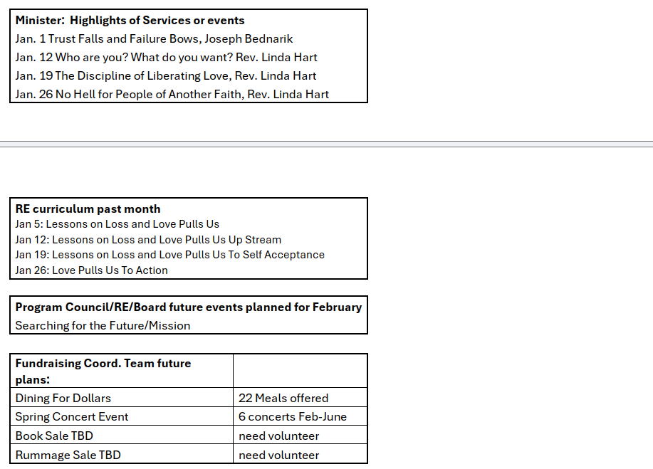
Return to Agenda
Attachment I
Personnel Committee
Policy Proposal: QUUF Policy for Severance for Employees
QUUF offers a fair and reasonable severance package to assist employees who are terminated involuntarily due to job restructure, being laid off or reduction in force, or budget cuts. This intent aligns with Unitarian Universalist values and with QUUF fiduciary responsibility.
This policy ensures that QUUF:
- Will provide a minimum of two weeks’ notice.
- Agrees to pay one week of current wage for each year of full-time service, or equivalent, up to a maximum of eight weeks.
- Agrees to provide references.
- Will allow the employee to be on COBRA at the employee’s own expense.
- Agrees that both parties will not make negative public statements about the other.
- The departing employee agrees to waive any legal claims against the organization in exchange for the severance package.
- QUUF will cash out vacation leave but not sick leave, but will reinstate the sick leave balance if employee is rehired within 12 months.
Rational:
According to a 2009 survey by Hewitt Associates, more than half (51%) of companies offer a standard one-to-two weeks of pay for every year of service and another third (33%) vary their payouts based on a formula that typically combines years of service, salary level and/or grade.
Employers are not obliged to give severance pay. The law only requires an employer to give severance if it has been promised in a contract (as in a minister), or stated in an employee handbook, or if there is an established pattern of giving severance to other employees in similar circumstances. Some employers choose to offer severance pay to employees who are terminated, either involuntarily or voluntarily.
- It can help protect the employee's finances and provide support as they transition to a new role.
- It can also help protect the nonprofit's reputation by offering a fair and reasonable package.
- The primary reasons for offering a severance package are to soften the blow of an involuntary termination and to avoid future lawsuits by having the employee sign a release in exchange for the severance.
- If the employee was terminated for cause, they typically receive nothing beyond what they were due before termination.
Return to Agenda

Attachment J
Agenda Items

QUUF BOARD GOALS
2024-2025

QUUF BOARD GOVERNANCE GOALS

ONGOING GOALS:
- Align Board practices with the Board Covenant, QUUF Mission, By-laws, policies, and shared governance model
- Maintain fiduciary responsibilities including financial and governance oversight
- Maintain oversight of the Developmental Ministry Goals
- Maintain oversight of the Developmental Minister contract and timely evaluations
- Maintain regular collaboration with Board Committees: Governance, Personnel, Denominational Affairs, Finances, RAMP and with the Endowments and the Nominating Committee
- Recommend policy development and bring policies and procedures to the Fellowship for approval
- Review By-Laws and recommend revisions or additions to the Fellowship

NEAR-TERM GOALS:
- Develop new Mission and Vision Statements
- Articulate a plan to involve the Fellowship, including timelines (beginning this fall and to be completed this spring) and communications with the Fellowship (October-November)
- Appoint a task force to research models for this process and enact a plan (October-November)

- Explore and recommend best practices for the QUUF Nominating Committee. Any recommended changes would be implemented in the QUUF calendar year beginning July 1, 2025.
- Assemble a collaborative team including representatives from the Nominating Committee, the Governance Committee, a Board representative and other leaders to research and make recommendations beginning October-November.
- Explore best practices in other UU congregations
- Clarify implications for QUUF:
Define the Board member's role on the committee
Determine feasibility to expand responsibilities for non-elected leadership recruitment
Determine potential for creating leadership development activities for example:
Pathways to service model
Effective presentations, information sessions, resources and training opportunities
Diversity, Equity and inclusion considerations
- Prepare a realistic description of Board service responsibilities, needed skills, etc.
B Prepare a recommendation to the Board so that any proposed By-laws changes can be put to a vote at the June 2024 Congregational meeting.

- Collaborate with the Program Council and Minister to assess progress on Developmental Ministry goals (December 2024, May 2025)

LONG-TERM GOALS
(projected for Fall, 2025)
- Activate a process for long-range planning and developing strategic goals

- Initiate a Search Committee for a called Minister

QUUF BOARD FINANCIAL GOALS

NEAR-TERM GOAL

- Assess the current budget according to costs associated with Programs and major activities, and continue to search for ways to increase income
- Develop standard report forms for use in reporting key current conditions and actions, as well as future plans, in a manner to allow for easier summarization and communication of the state of the Fellowship financially and spiritually – October 16, 2024
- Create a financial “dashboard” to be included with the Treasurer’s Report To The Board to show key metrics of financial current status and forecasts through the end of the church year – October 16, 2024
- Review current recurring expenses, such as insurance, subscriptions, utilities and look for ways to update coverage and possibly reduce costs – December 15, 2024
- Search for grants, Fund-A-Needs, unrestricted gifts, rentals, and other sources of income – Ongoing

MEDIUM-TERM GOAL

- Propose options, including pros and cons, for the Board to consider in restructuring QUUF for the 2025-2026 balanced budget goal

- Forecast fundraising and income expectations, including shortfalls from goals – November 20 2024 and February 12, 2025
- Develop scenarios for expense reduction, including pros and cons – February 12, 2025

LONG-TERM GOAL

- Create a long-range vision and plan for a sustainable financial future

- Revise Program and Mission to align with a financially sustainable level of services that will maintain QUUF as a healthy, vibrant, UU congregation for the next five years and beyond – April 16, 2025

QUUF BOARD COMMUNICATION GOALS

ONGOING GOALS

Maintain regular communication with the congregation through the following:
- Weekly Update notifications
- Announcements from the pulpit
- Monday Board Reports (may be submitted by any member of the board)
- Responses to Letters to the Board

NEAR-TERM GOALS

- Record, submit, and update Board Procedures to add to the Procedural Manual (January 2025)
- Establish a working team to write up procedures (November)
- Meet as needed to update procedures (ongoing)
- Collaborate with the Nominating Committee to plan and conduct elections in April.
- Work with the Nominating Committee to set a date for annual Elections (October)
- Specify the open positions for next year on Nominations, Endowments, and the Board.
- Organize a sub-committee to determine tasks and objectives for the January Congregational Meeting
Starting in November:
- Establish timelines for informing the Fellowship
- Prepare the agenda
- Prepare budget information and related materials
- Develop training modules for new Board members and establish training schedule.
- Determine who will take the lead on training. (March 2025)
- Review existing materials and resources and identify any additional needs
- Organize and conduct the Annual Meeting (Starting in March and April):
- Establish timelines for informing the Fellowship
- Prepare the agenda
- Prepare budget materials and related materials
Return to Agenda
Attachment K
Preparation for Developmental Ministry Goals

This year I think we did a good job "living into" our governance model by integrating our Developmental Ministry goals throughout our organization with supportive Board goals and Program Council goals. We have made good progress through our shared efforts. It is time to formulate goals and priorities for Linda's 2025-26 contract (in March) and these will encompass coordinated efforts once more. Whereas the initial set of developmental ministry goals was based on the Search Committee's assessment of QUUF’s priority needs in January of 2022, we are working from a more unified, confident and hopeful position 3 years later. It seems like more focus on ministry and program issues are appropriate for our next phase. This remaining interim time is intended to prepare the Fellowship for a transition and acceptance of change on our horizon.

Here are a few of my thoughts I shared with the Program Council teams as a jumping off point for suggesting next steps and creative ideas:
- How are we doing with nurturing belonging, welcome, covenantal relationships and meaningful engagement with our membership?
- How are we proactively engaging with the needs and priorities of our members who are still in their parenting and working years? Are there implications for spiritual growth programs, worship patterns, classes, support groups or events?
- How do current events impact our need to engage the congregation with information, discussions, actions etc.?
- What do we need to do to prepare the Fellowship for the specific processes of calling a minister?
- What aspects of our programs, leadership needs, and training opportunities can be addressed?
- Are there additional policies, procedures or other governance issues to address?
These same questions, and more, are also relevant to the work that we will be asking an appointed Long-Range Planning Committee to engage in. We need to develop the expectations for the work of that group and get them launched. My target is late spring.

Return to Agenda

Attachment L
Pending Policy for Donation Jar

The Finance Committee recommends this policy to the board for approval:

Donation Jar Policy for free public events held at QUUF
FREE Public events (coordinated by QUUF) and held at QUUF will have a donation jar available for voluntary donations to QUUF.

“Public events” for this Policy are defined as:
- The event is open to the general public and QUUF members
- The event is held at the QUUF campus
- QUUF has not received a rental payment for the event
- The event is not a QUUF fundraising event (like auction or Dining for Dollars)
- The event is free

Procedure
- Donation jar is located in the office. Event organizer picks up the Donation Jar and is responsible for displaying the Donation Jar at the event.
- After the event, the event organizer retrieves the money, puts the donations in an envelope with event name/attendance numbers, and puts the envelope in the office safe or the black box outside the office.
- Funds from the donation jar are retrieved for the regular weekly deposit and credited to the Operating Fund.

The procedure would be placed in the Financial Handbook and can be modified by the Finance committee. The Policy would apply to all events.

Return to Agenda

